WKU Writing Project

Technology Tools for Literacy
Dr. Angela Gunter angela.gunter@daviess.kyschools.us
Resource Page: gunter-english.weebly.com/
Click on “Tech Tools for Literacy”

Formative Assessment

Argument Writing, Searching, Organization

Blogspot, Schoology, Weebly, Wiki
(all are free and user-friendly)
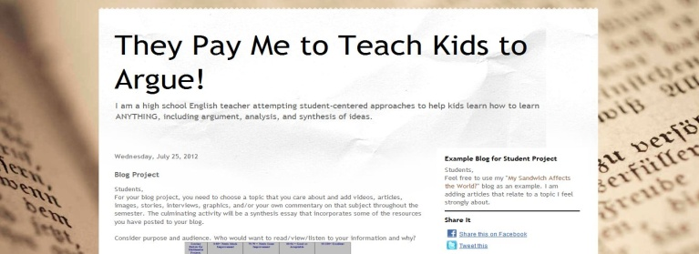

Flip Your Class/
Incorporate Blended Learning
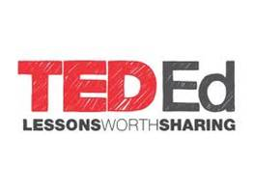

Find high-frequency SAT/ACT words

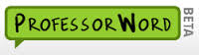

Comment on or make connections in pictures/photos

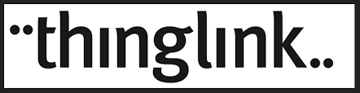

Students create infographics

Classroom Management System
(similar to Edmodo, Moodle, etc.)

Organize online writing

