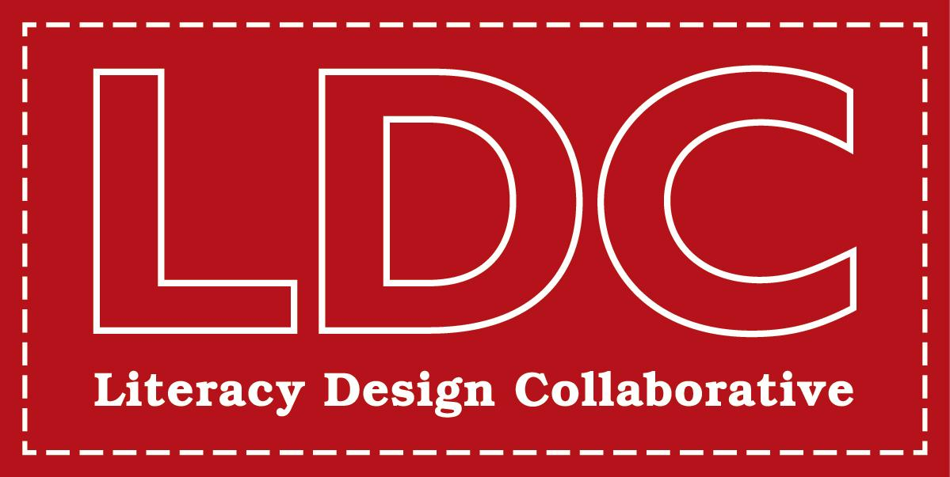

LDC Feedback Checklist—PAS-4
Formative assessment of teacher learning and work is an ongoing process of continuous improvement. This checklist provides some guidance for thinking about how to structure your feedback to an author. Use this checklist to see if your feedback is ready to share with the teacher/author you are supporting.

 |  | YES | NO
Prioritized | - Does the feedback focus on the highest leverage move the author can make to improve the task?
Actionable | - Is the feedback something the author can easily see how to immediately change or revise?
Specific | - Is the feedback evidence-based? Does it reference particular rubric language or point out specific evidence in the artifact?
 | - Does the feedback include specific examples the teacher can use as models? For example: re-written prompts, a link to an artifact in LDC CoreTools, student-facing prompts?
Standards- Driven | - Is the feedback directly driven by standards? Does it include the language of a standard and/or a standard itself?
Supportive | - Is the feedback supportive of the author’s work and learning? Will the feedback motivate the author to continue to revise, edit, and create?
Short | - Is the feedback short, concise, easy to read, and easy to follow?

