Compare/Contrast Visual Literacy Name:
Step 1: Both of the sculptures presented are named The Kiss. Consider differences and similarities. List in the diagram below. 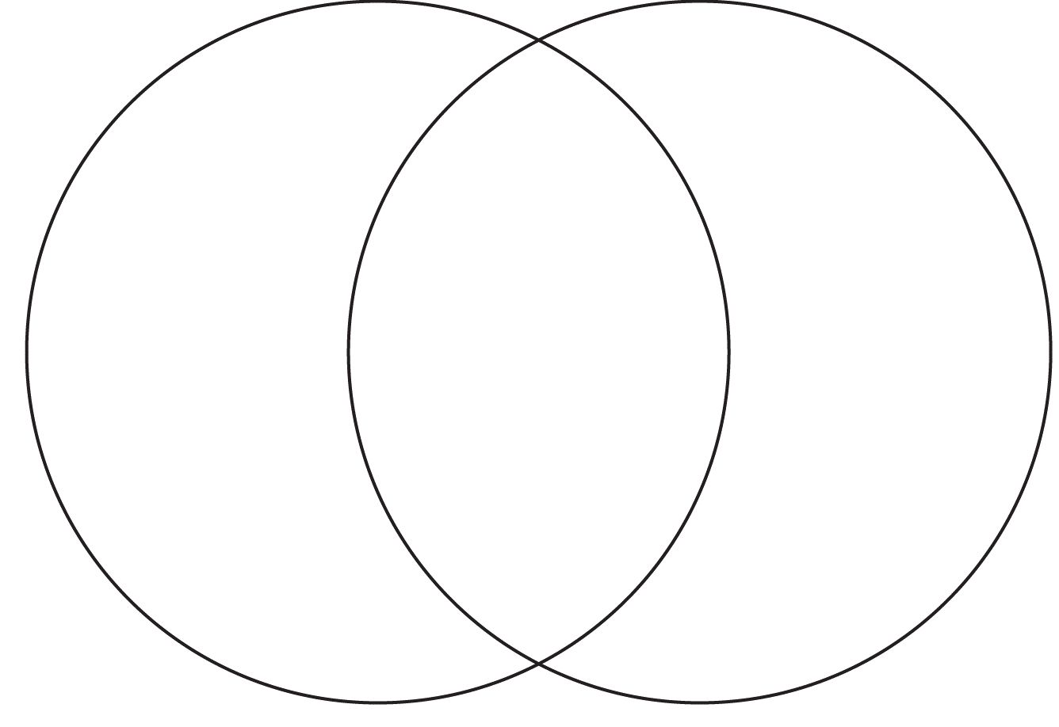

Step 2: Compile the list above into THREE major categories. Which attributes listed above would belong to each category?

Category 1: ___________________ Category 2: ___________________ Category 3: _____________________
- 1. 1.
- 2. 2.

Step 3: Consider that both of these sculptures are arguments. What are their sculptors arguing? Go beyond the concrete/literal (universal truth).

Step 4: Metacognition: Why are you being asked to complete this activity?

